Day 1 Lab Instructions – Azure AI Platform

Contents

Lab 01: Introduction to LLMs and Azure AI Services 2

Task 1 :Introduction to LLMs and Azure AI Services 2

Task 02: Create AI model deployments 4

Deploy gpt-4o-mini and text-embedding-ada-002 models 5

Task 3: RAG : 12

Task 3.a: Add data and create a search index 12

Task 3.b: Use Playground to chat with your data 12

Task 4: Setup Azure AI Content Safety 13

Task 04.b: Test the prompt in Content Safety 13

Task 5 ; Execute the Python Notebooks 13

5.a Execute the Gpt 4.1 Python notebook and see how the results 13

5.b Execute the o4 mini Python notebook and see how the results 13

**Day 1**

# Lab 01: Introduction to LLMs and Azure AI Services

## Task 1 :Introduction to LLMs and Azure AI Services

In this lab, we will have an overview on how to use Azure AI to work with large language models.

The focus will be more on an overview of the creation process, so that in the next lessons we will delve deeper into the build, evaluation, deployment, and monitoring process.

**Prerequisites**

An Azure subscription is required, where you can create an AI Project along with its **AI Hub Resource, a Content Safety service, and an AI Search service**.

**Setup**

* [Create an AI Project and AI Hub Resources](https://github.com/microsoft/llmops-workshop/blob/main/labs/lesson_01/lab01.md#create-an-ai-project-and-ai-hub-resouces)
* [Deploy an Azure OpenAI model](https://github.com/microsoft/llmops-workshop/blob/main/labs/lesson_01/lab01.md#deploy-an-azure-openai-model)

**Lab Steps**

1. Use AzureAI Foundry Model Playground.
2. Work with an Open Source LLM Model.
3. Test the prompt in Content Safety.

**Setup**

**Create an AI Project and AI Hub Resources**

Let's start by creating a project in Azure AI Studio.

Go to your browser and type: [https://ai.azure.com](https://ai.azure.com/)

After logging in with your Azure account, you will see the following screen:



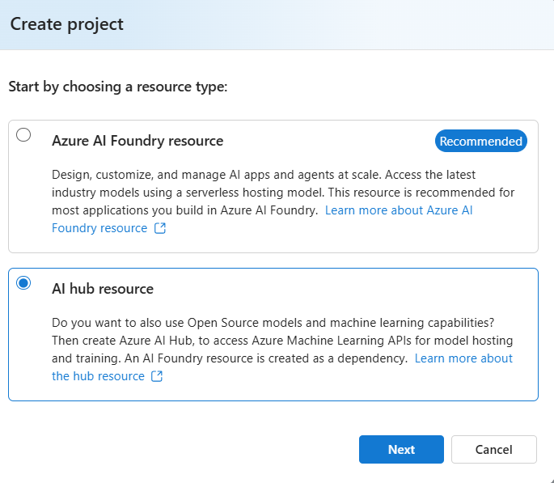

Rename the hub

**Project creation will progress (will take 1 to 2 minutes)**

Then you will land with below page

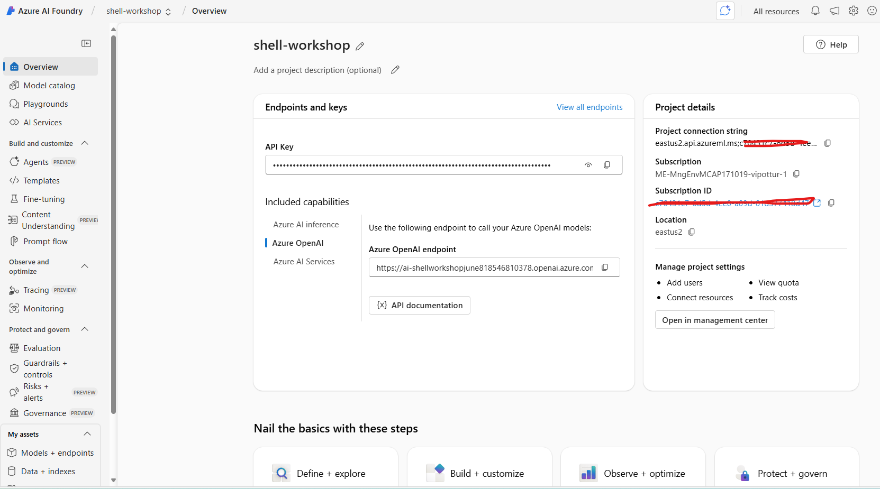

## Task 02: Create AI model deployments

In this task, you’ll deploy the **gpt-4o** and **text-embedding-ada-002** models to your project. These models are necessary for creating an AI-assisted chat application.

**Deploy an Azure OpenAI model**

After creating your AI Project, the first step is to create a deployment of an OpenAI model so you can start experimenting with the prompts you will use in your application.

### Deploy gpt-4o-mini and text-embedding-ada-002 models

To do this, access your newly created project in the AI foundry, select the **Model+end points** option, and click on **deploy base model** From the list of models, select **gpt-4o**

On the next screen, define the name of the deployment, in this case, you can use the same name as the model and in the version field select the latest available version, in the example below. Now, just click on **Deploy** and your model deployment is created. You can now test it in the Playground.

1. Once deployed, select the back button to return to the **Manage deployments of your models and services** page and deploy another base model.
2. For this one, select **text-embedding-ada-002**, then select **Confirm**.

1. Ensure the **Deployment type** is set to Global **Standard**, then select **Deploy**.

**Note above lab steps are here – Images may not match exactly as product is evolving so rapidly.**

[**https://microsoft.github.io/TechExcel-Transform-Data-and-AI-solutions-with-Azure-AI-Platform/docs/Ex01/0101.html**](https://microsoft.github.io/TechExcel-Transform-Data-and-AI-solutions-with-Azure-AI-Platform/docs/Ex01/0101.html)

**Lab Steps**

[**https://github.com/microsoft/llmops-workshop/blob/main/labs/lesson_01/lab01.md#lab-steps-1**](https://github.com/microsoft/llmops-workshop/blob/main/labs/lesson_01/lab01.md#lab-steps-1)

**1) Use AzureAI foundry Model Playground**

On the screen with the deployment information, select the **Open in playground** button.

[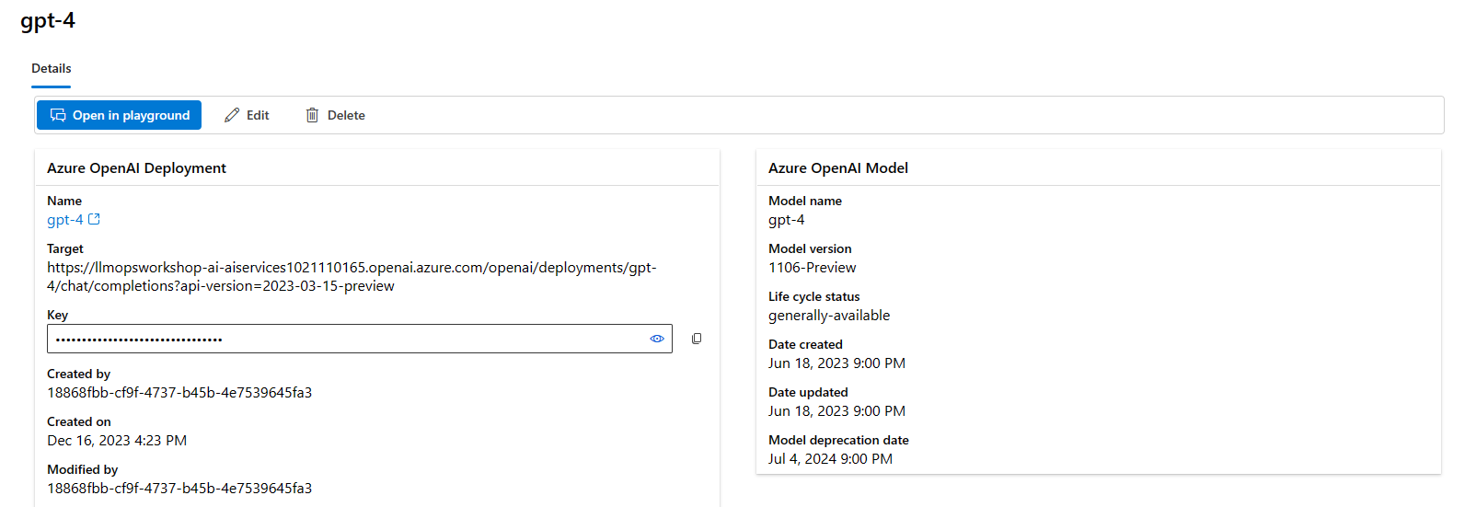](https://github.com/microsoft/llmops-workshop/blob/main/labs/lesson_01/images/16.12.2023_16.29.30_REC.png)

In this lab, we will run an example where the model will help us summarize and extract information from a conversation between a customer and a representative of a telco company.

Copy the following prompt into the system message field of the playground:

You're an AI assistant that helps telco company to extract valuable information from their conversations by creating JSON files for each conversation transcription you receive. You always try to extract and format as a JSON:

1. Customer Name [name]

2. Customer Contact Phone [phone]

3. Main Topic of the Conversation [topic]

4. Customer Sentiment (Neutral, Positive, Negative)[sentiment]

5. How the Agent Handled the Conversation [agent_behavior]

6. What was the FINAL Outcome of the Conversation [outcome]

7. A really brief Summary of the Conversation [summary]

Only extract information that you're sure. If you're unsure, write "Unknown/Not Found" in the JSON file.

After copying, select **Apply changes**

[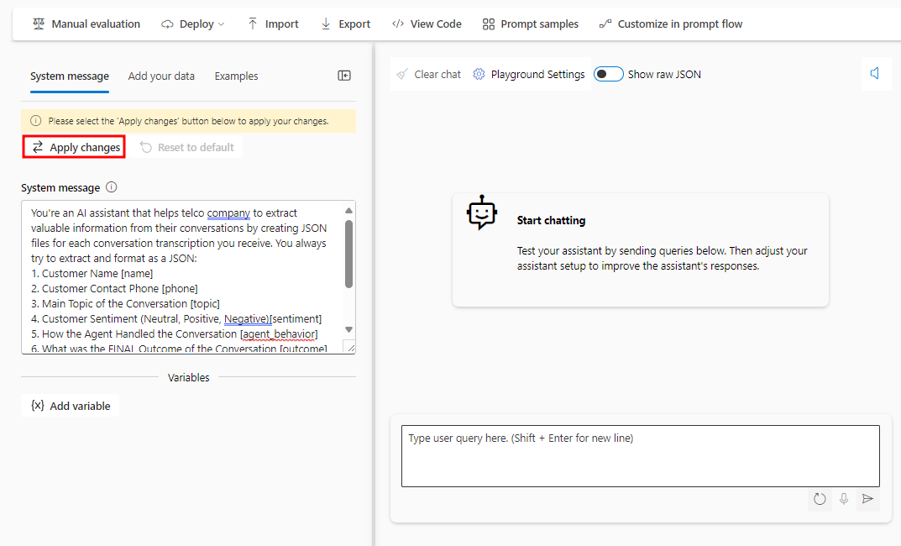](https://github.com/microsoft/llmops-workshop/blob/main/labs/lesson_01/images/06.02.2024_21.48.36_REC.png)

Then type the following text in the chat session and click the send button:

Agent: Hello, welcome to Telco's customer service. My name is Juan, how can I assist you?

Client: Hello, Juan. I'm calling because I'm having issues with my mobile data plan. It's very slow and I can't browse the internet or use my apps.

Agent: I'm very sorry for the inconvenience, sir. Could you please tell me your phone number and your full name?

Client: Yes, sure. My number is 011-4567-8910 and my name is Martín Pérez.

Agent: Thank you, Mr. Pérez. I'm going to check your plan and your data usage. One moment, please.

Client: Okay, thank you.

Agent: Mr. Pérez, I've reviewed your plan and I see that you have contracted the basic plan of 2 GB of data per month. Is that correct?

Client: Yes, that's correct.

Agent: Well, I inform you that you have consumed 90% of your data limit and you only have 200 MB available until the end of the month. That's why your browsing speed has been reduced.

Client: What? How is that possible? I barely use the internet on my cell phone. I only check my email and my social networks from time to time. I don't watch videos or download large files.

Agent: I understand, Mr. Pérez. But keep in mind that some applications consume data in the background, without you realizing it. For example, automatic updates, backups, GPS, etc.

Client: Well, but they didn't explain that to me when I contracted the plan. They told me that with 2 GB I would have enough for the whole month. I feel cheated.

Agent: I apologize, Mr. Pérez. It was not our intention to deceive you. I offer you a solution: if you want, you can change your plan to a higher one, with more GB of data and higher speed. This way you can enjoy a better browsing experience.

Client: And how much would that cost me?

Agent: We have a special offer for you. For only 10 pesos more per month, you can access the premium plan of 5 GB of data and 4G speed. Are you interested?

Client: Mmm, I don't know. Isn't there another option? Can't you give me more speed without charging me more?

Agent: I'm sorry, Mr. Pérez. That's the only option we have available. If you don't change your plan, you'll have to wait until next month to recover your normal speed. Or you can buy an additional data package, but it would be more expensive than changing plans.

Client: Well, let me think about it. Can I call later to confirm?

Agent: Of course, Mr. Pérez. You can call whenever you want. The number is the same one you dialed now. Is there anything else I can help you with?

Client: No, that's all. Thank you for your attention.

Agent: Thank you, Mr. Pérez. Have a good day. Goodbye.

[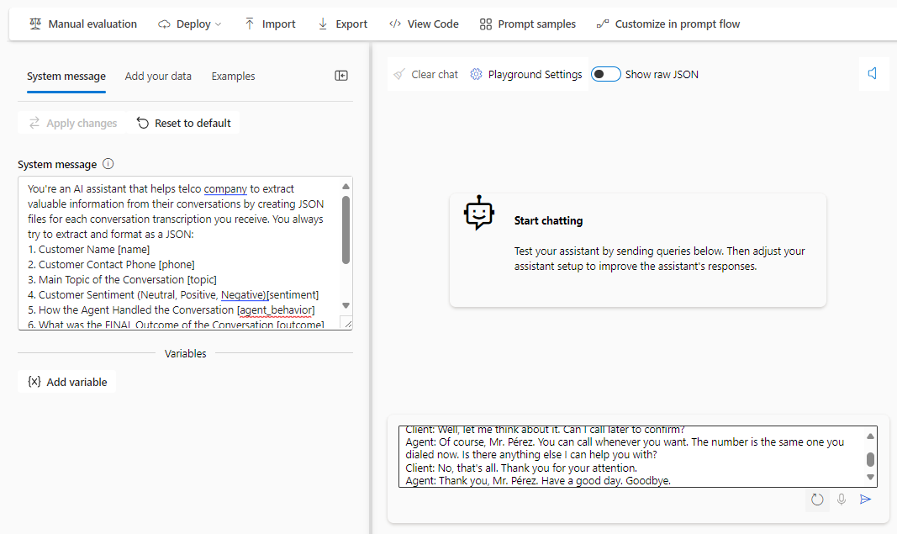](https://github.com/microsoft/llmops-workshop/blob/main/labs/lesson_01/images/06.02.2024_21.49.26_REC.png)

You will see a result generated by the model similar to the one shown in the image below.

Notice that the model correctly followed the instructions indicated in the System message field:

[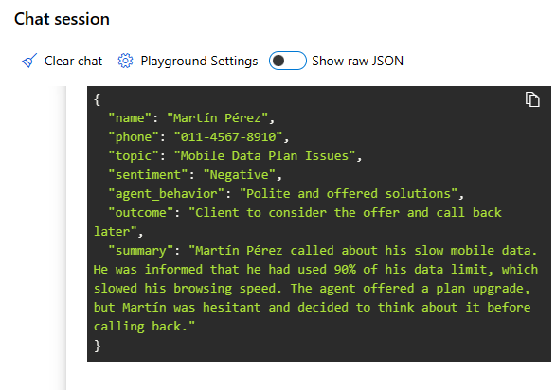](https://github.com/microsoft/llmops-workshop/blob/main/labs/lesson_01/images/16.12.2023_16.48.13_REC.png)

## Task 3: RAG :

Creating a search service

<https://microsoft.github.io/TechExcel-Transform-Data-and-AI-solutions-with-Azure-AI-Platform/docs/Ex01/0103.html>

### Task 3.a: Add data and create a search index

<https://microsoft.github.io/TechExcel-Transform-Data-and-AI-solutions-with-Azure-AI-Platform/docs/Ex02/0202.html>

### Task 3.b: Use Playground to chat with your data

<https://microsoft.github.io/TechExcel-Transform-Data-and-AI-solutions-with-Azure-AI-Platform/docs/Ex02/0203.html>

## Task 4: Setup Azure AI Content Safety

[**https://microsoft.github.io/TechExcel-Transform-Data-and-AI-solutions-with-Azure-AI-Platform/docs/Ex05/0501.html**](https://microsoft.github.io/TechExcel-Transform-Data-and-AI-solutions-with-Azure-AI-Platform/docs/Ex05/0501.html)

### Task 04.b: Test the prompt in Content Safety

<https://github.com/microsoft/TechExcel-Operationalize-LLMs-with-LLMOps-automation/blob/main/docs/01_intro_to_llms/01_03.md>

## Task 5 ; Execute the Python Notebooks

### 5.a Execute the Gpt 4.1 Python notebook and see how the results

### 5.b Execute the o4 mini Python notebook and see how the results